FL 2026 general — final week (main sample, provisional)
  - Public results

At a glance
Population | FL likely voters for the November 3, 2026 general election
Field dates | October 30–October 31, 2026
Completed interviews | 2,898
Ballot bases | 60–2,898
Weighted effective n | 2,120
Sampling-equivalent precision | ±2.1 percentage points for the full sample (effective n 2,120); ±2.1 to ±16.9 on ballot items with bases of 60–2,898
Weighting model | AFWH house rule (tied-set average; 98% on recipes held to recalled vote among voter-file-verified 2024 voters; 2% on recipes held to all recalled vote)

Ballot snapshot
The percentages below are weighted shares among respondents who answered each ballot item. Undecided voters are shown separately and are not allocated to a candidate.
- Senate ballot choice: Ashley Moody, Republican 47.9%; Angie Nixon, Democrat 44.7%; Prefer not to answer 3.8%; Neil J. Gillespie, No Party Affiliation 0.9%; Did not vote in this race 0.6%; Someone else 0.5%; Undecided 1.6%.
- If you had to decide today, which candidate would you lean more toward?: Ashley Moody, Republican 23.2%; Angie Nixon, Democrat 9.4%; Neil J. Gillespie, No Party Affiliation 7.8%; Someone else 4.3%; Undecided 55.3%.
- Are you definitely or probably going to vote for that candidate?: Definitely 90.1%; Probably 7.5%; Don't know / No opinion 2.4%.
- Governor ballot choice: Byron Donalds, Republican 47.5%; David Jolly, Democrat 45.7%; Prefer not to answer 2.9%; Scott Eckhard Jewett, Libertarian 0.9%; Charles Burkett, No Party Affiliation 0.3%; Did not vote in this race 0.3%; Dean Ocean Abrams, No Party Affiliation 0.1%; Frank J. Russo, No Party Affiliation 0.1%; Jeffrey Peter "Dr. Jeff" Datto, No Party Affiliation 0.0%; Moliere "Moe" Dimanche, No Party Affiliation 0.0%; Someone else 0.9%; Undecided 1.4%.
- If you had to decide today, which candidate would you lean more toward?: Byron Donalds, Republican 22.9%; David Jolly, Democrat 6.7%; Scott Eckhard Jewett, Libertarian 1.9%; Charles Burkett, No Party Affiliation 0.4%; Frank J. Russo, No Party Affiliation 0.3%; Someone else 2.6%; Undecided 65.4%.
- Are you definitely or probably going to vote for that candidate?: Definitely 90.7%; Probably 7.2%; Don't know / No opinion 2.1%.
- When did you cast your ballot in the November 3, 2026 general election? If you voted by mail, please tell us when you mailed or returned your ballot.: October 24 or later 49.7%; On or before October 23 40.0%; Don't know / No opinion 10.2%.
- How did you cast your ballot in the November 3, 2026 general election?: In person at an early voting location 62.9%; By mail 23.6%; By returning a mail ballot to a drop box or election office 9.4%; In person on Election Day 2.0%; Don't know / Prefer not to answer 1.4%; Another way 0.6%.
- How do you currently plan to cast your ballot in the November 3, 2026 general election?: In person on Election Day 62.1%; In person at an early voting location 29.7%; Not sure yet 3.1%; By returning a mail ballot to a drop box or election office 2.3%; I do not plan to vote 1.6%; By mail 1.2%; Another way 0.1%.
- When do you currently plan to cast or return your ballot? If voting by mail, please tell us when you plan to mail or return it.: Before Election Day, November 3 63.9%; On Election Day, November 3 26.5%; Not sure yet 7.5%; I do not plan to vote 1.8%; After Election Day, November 3 0.4%.

Ballot

Senate ballot choice
Base n=2,898 · effective n=2,120
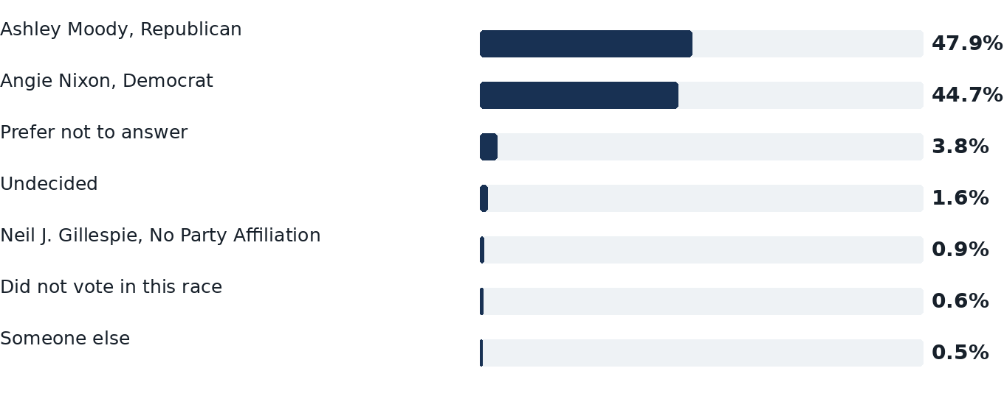

If you had to decide today, which candidate would you lean more toward?
Base n=74 · effective n=45
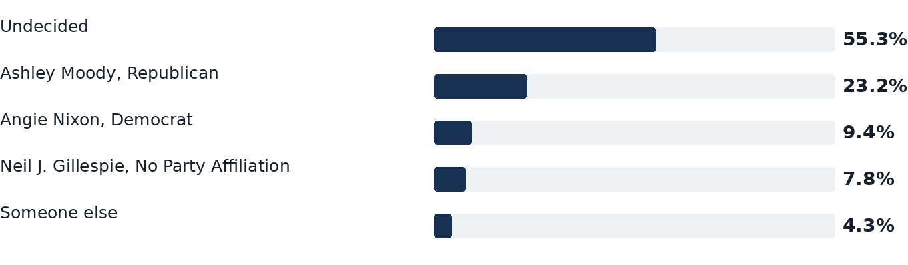

Are you definitely or probably going to vote for that candidate?
Base n=685 · effective n=460
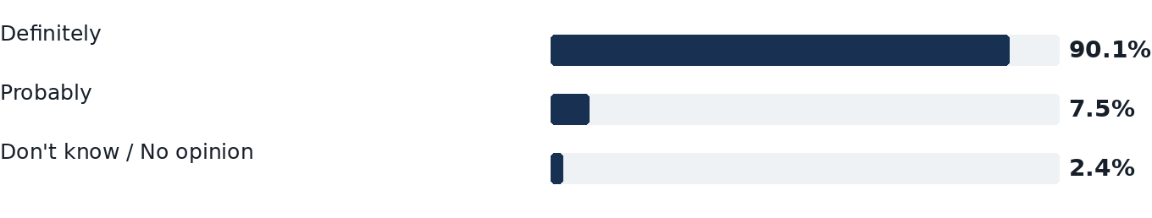

Governor ballot choice
Base n=2,898 · effective n=2,120
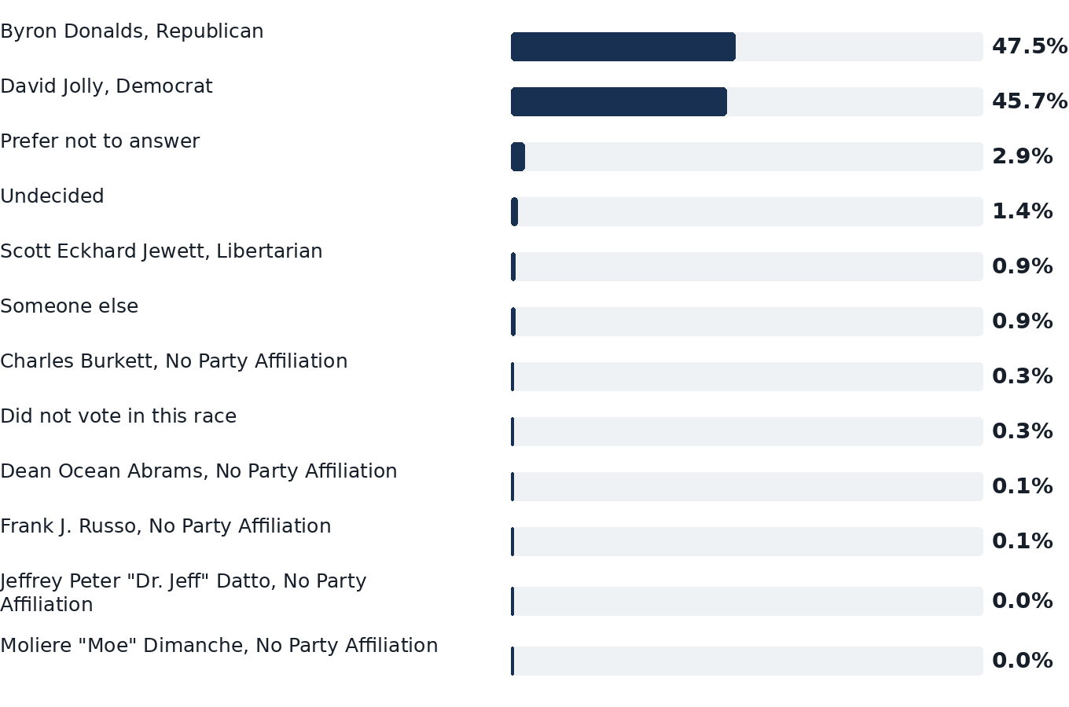

If you had to decide today, which candidate would you lean more toward?
Base n=60 · effective n=34
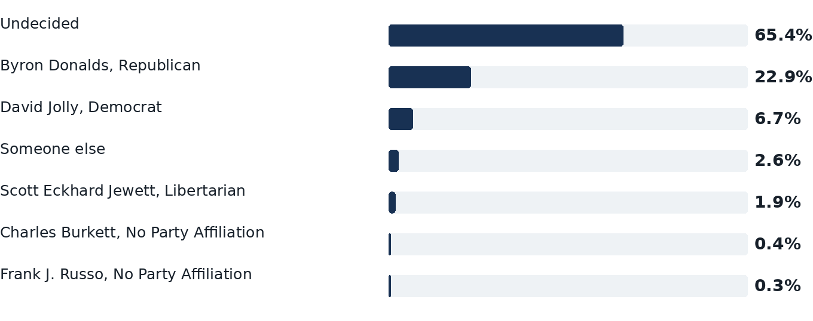

Are you definitely or probably going to vote for that candidate?
Base n=694 · effective n=468
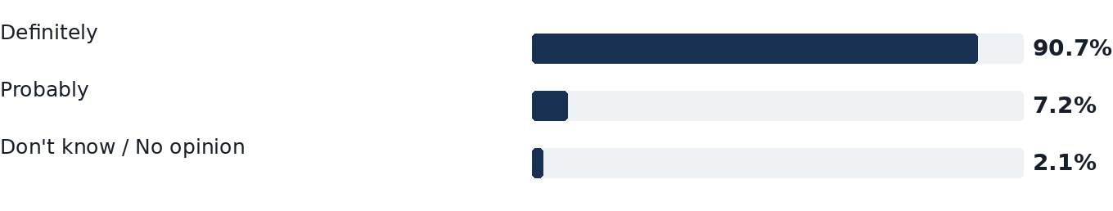

When did you cast your ballot in the November 3, 2026 general election? If you voted by mail, please tell us when you mailed or returned your ballot.
Base n=2,119 · effective n=1,611
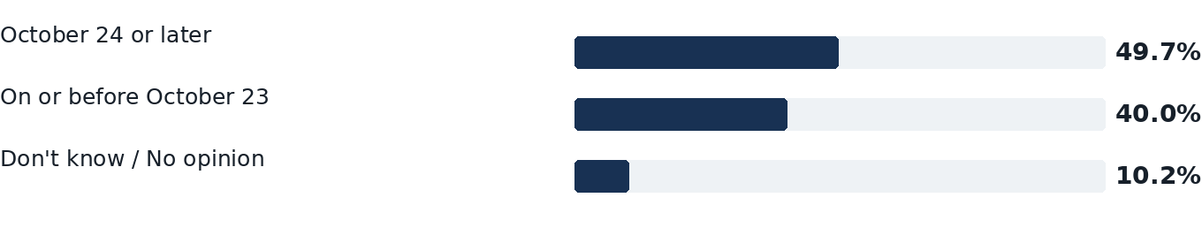

How did you cast your ballot in the November 3, 2026 general election?
Base n=2,119 · effective n=1,611
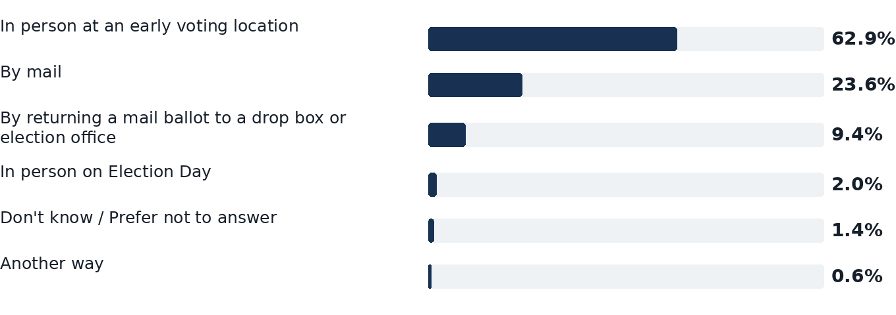

How do you currently plan to cast your ballot in the November 3, 2026 general election?
Base n=779 · effective n=516
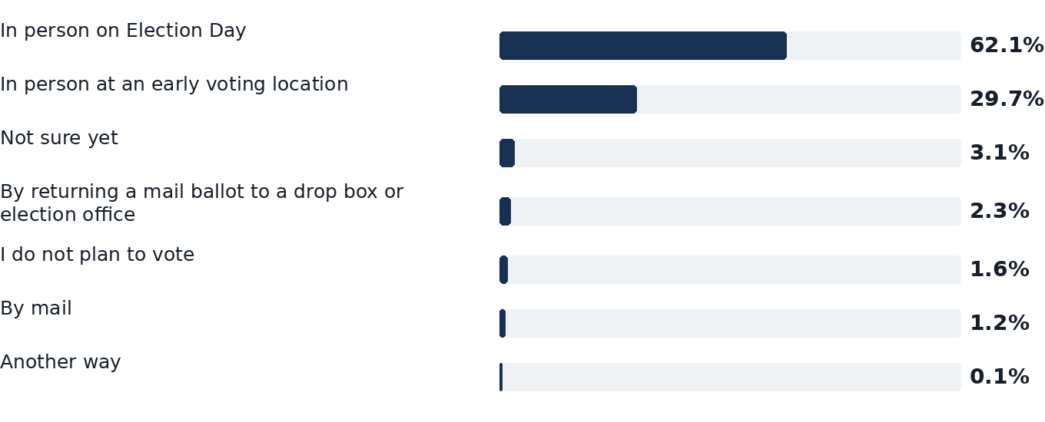

When do you currently plan to cast or return your ballot? If voting by mail, please tell us when you plan to mail or return it.
Base n=304 · effective n=203
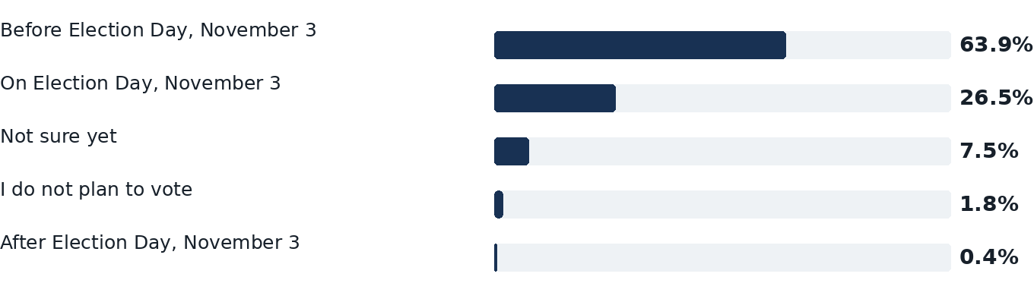

Issues

Who did you vote for in the 2024 presidential election between Donald Trump and Kamala Harris, or did you not vote?
Base n=2,898 · effective n=2,120
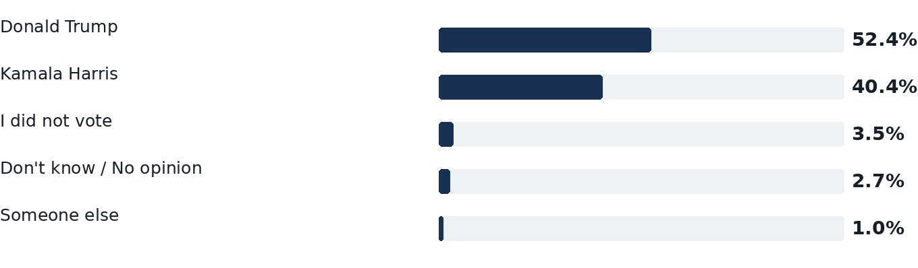

How much have you thought about this election?
Base n=2,898 · effective n=2,120
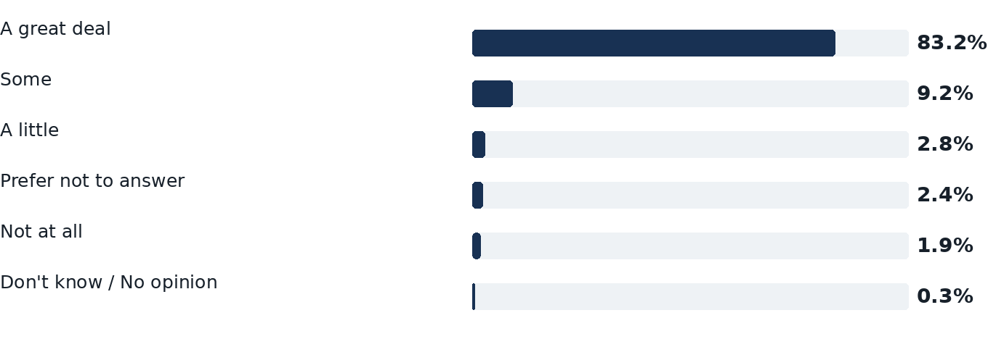

When it comes to the November election, would you say you are very enthusiastic about voting, somewhat enthusiastic, not very enthusiastic, or not at all enthusiastic?
Base n=779 · effective n=516
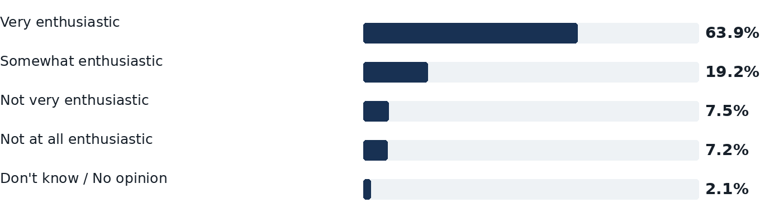

On a scale from 0 to 9, where 0 means you definitely will not vote and 9 means you definitely will vote, how likely are you to vote in this election?
Base n=779 · effective n=516
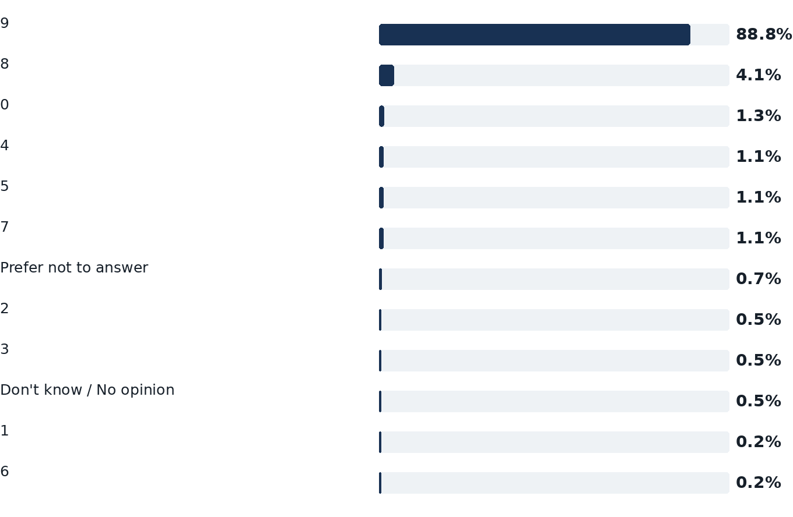

Thinking back to when you cast your ballot, how did you feel about voting in this election?
Base n=2,119 · effective n=1,611
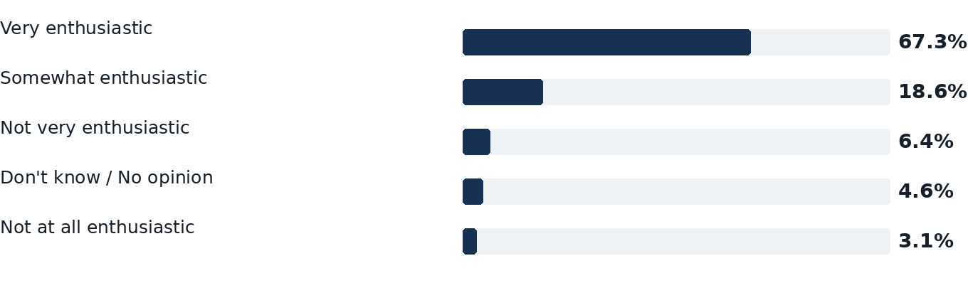

If Democrats win control of the Senate in the 2026 election, which of these people would you prefer to see as Senate Majority Leader?
Base n=2,898 · effective n=2,120
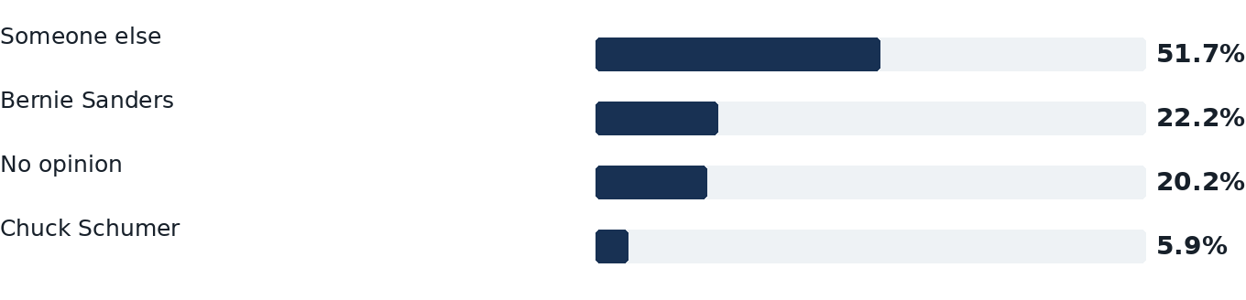

If Democrats win control of the House of Representatives in the 2026 election, which of these people would you prefer to see as Speaker of the House?
Base n=2,898 · effective n=2,120
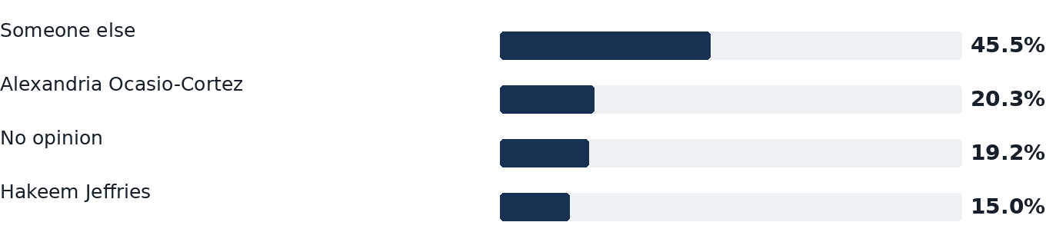

Projected electorate
Weighting targets describe the projected electorate; they are not survey findings.
Dimension | Category | Projected share
Party registration | Republican | 45.6%
Party registration | Democrat | 32.8%
Party registration | No party affiliation (NPA) | 19.0%
Party registration | Conservative | 0.1%
Party registration | Green | <0.1%
Party registration | Libertarian | 0.2%
Party registration | Other minor parties | 2.2%
Gender | Female | 53.3%
Gender | Male | 46.5%
Gender | Another gender or not reported | 0.2%
Age | 18-29 | 6.8%
Age | 30-44 | 15.1%
Age | 45-54 | 13.6%
Age | 55-64 | 20.1%
Age | 65+ | 44.3%
Region | North | 23.9%
Region | Central | 18.0%
Region | Tampa Bay | 22.2%
Region | Southwest | 8.6%
Region | Southeast | 16.8%
Region | Miami-Dade | 10.5%
Race and ethnicity | Asian or Pacific Islander | 1.8%
Race and ethnicity | Black | 10.6%
Race and ethnicity | Other or multiracial | 2.2%
Race and ethnicity | White | 71.4%
Race and ethnicity | Hispanic or Latino | 14.0%
2024 presidential vote (recalled) | Didn't vote or other (2024) | 9.2%
2024 presidential vote (recalled) | Harris | 40.0%
2024 presidential vote (recalled) | Trump | 50.8%
Education (college degree) | College degree | 39.7%
Education (college degree) | No college degree | 57.5%
Education (college degree) | Unknown | 2.8%

Methodology
RedBox Research analyzed this survey among FL likely voters for the November 3, 2026 general election. The analysis includes 2,898 completed interviews; routed questions use their own recorded bases. Where voting status routed respondents to past-vote or vote-intent wording, the two mutually exclusive paths are combined into one contest estimate; each respondent is counted once. Completed interviews were adjusted using a weighted average of several raking recipes' weights to the recorded electorate targets for Age, Congressional district, Education (college degree), Gender, Party registration, Race and ethnicity, 2024 presidential vote (recalled). On ballot items, the questionnaire response 'Not sure' is reported as 'Undecided'; no undecided or other responses are allocated. The stated precision is sampling-equivalent only; coverage, nonresponse, measurement, and model error may add uncertainty.
The estimate is the AFWH house estimate, the average of the weighting recipes held to the 2024 vote that passed our checks for this poll: a weighted average of several raking recipes' weights, by family, 98.4% on recalled vote among verified 2024 voters and recalled vote among verified 2024 voters plus turnout groups; 1.6% on recalled-vote recipe and recalled-vote recipe plus turnout groups. In every recipe, each likely voter counts by their chance of voting from our likely-voter model. Each recipe in the estimate raked the design weights to its targets with no bound on the adjustment, then trimmed its final weights at their 1st and 99th percentiles and raked them again; averaging the recipes trimmed no weight. The 2024 presidential vote target is not the certified result: it is Harris 43.6%, Trump 55.4% and everyone else 0.9% of the 2024 vote (Harris 44.0% of the Harris and Trump vote). Source: The 2024 presidential vote of this year's projected Florida electorate, from voter-file 2024 vote history and certified county and precinct results (Harris 42.7% of the two-party vote among projected voters with a 2024 vote record), adjusted for the rate at which voters now misremember their 2024 vote, as measured by re-interviewing the same panelists (G. Elliott Morris / Verasight, October 22, 2026): Harris 44.0% of recalled two-party vote. The 2024 presidential vote target was set on November 1, 2026, after fieldwork and after earlier results had been seen. The targets are weighted to the November 3, 2026 general electorate as the state's 2026 turnout verdict defines it: each margin from its own source, age group: the turnout model's predicted 2026 electorate, trained only on elections since 2016; congressional district: the turnout model's predicted 2026 electorate, trained only on elections since 2016; gender: the turnout model's predicted 2026 electorate, trained only on elections since 2016; party registration: midpoint of count completion at 2022 after-Friday pace and 2022 after-Friday conversion of 2026 not-yet-voted registrants, from Florida Division of Elections ballots by registered party as of the Division of Elections report of October 30, 2026, paired with the same pre-election day in 2022. Its party registration target was revised on October 31, 2026, after fieldwork and after earlier results had been seen; the verdict's other targets were set in advance. Race is weighted to the 2022 general electorate's composition by the race voters recorded on the state's voter file, with a verified surname-and-geography estimate for voters who recorded none.

Disclosure
Sponsored by A Fight Worth Having (super PAC, FEC C00933085); conducted by RedBox Research, AFWH's polling unit.
Population: Likely voters (AFWH house estimate) in the declared poll frame (FL); weighted to the November 3, 2026 general electorate as the state's 2026 turnout verdict defines it: each margin from its own source, age group: the turnout model's predicted 2026 electorate, trained only on elections since 2016; congressional district: the turnout model's predicted 2026 electorate, trained only on elections since 2016; gender: the turnout model's predicted 2026 electorate, trained only on elections since 2016; party registration: midpoint of count completion at 2022 after-Friday pace and 2022 after-Friday conversion of 2026 not-yet-voted registrants, from Florida Division of Elections ballots by registered party as of the Division of Elections report of October 30, 2026, paired with the same pre-election day in 2022. Its party registration target was revised on October 31, 2026, after fieldwork and after earlier results had been seen; the verdict's other targets were set in advance. Race is weighted to the 2022 general electorate's composition by the race voters recorded on the state's voter file, with a verified surname-and-geography estimate for voters who recorded none. The AFWH house estimate: the average of the weighting recipes held to the 2024 vote that passed our checks for this poll (recalled-vote recipe, recalled-vote recipe plus turnout groups, recalled vote among verified 2024 voters and recalled vote among verified 2024 voters plus turnout groups), each on our likely-voter model's turnout step, raked to the poll's electorate targets and to a 2024 presidential vote target of Harris 44.0% of the Harris and Trump vote through recalled 2024 vote and the Census college share of the geography's registered citizens. (FL).
Likely-voter rule: No question screened respondents out of the interview. Each respondent's voter-file turnout score was updated by their answer to the vote-intention question (Q13), with an odds ratio of 2.42 between the lowest and highest answers. Respondents who said they had already voted (Q1) counted as certain to vote; a missing answer kept the file score; anyone else whose file score was zero got no weight. Each respondent's weight was multiplied by the updated score before raking to the targets.
Each person counts by their chance of voting: the turnout score our voter-file model gives them, adjusted by how likely they said they are to vote.
Sample frame: 13,427,545 voter-file records in universe "FL 2026 general" (State: FL; Office: senate; Turnout model: AFWH's Florida turnout model, trained on the 2022 general election); random draw of 1,077; 223,636 sent a text invitation.
Sample frame: 458,052 voter-file records in universe "FL 2026 general — FL-13 geographic fill for the final-week statewide poll" (State: FL; Office: senate; Turnout model: AFWH's Florida turnout model, trained on the 2022 general election); random draw of 107.
Sample frame: 445,455 voter-file records in universe "FL 2026 general — FL-14 geographic fill for the final-week statewide poll" (State: FL; Office: senate; Turnout model: AFWH's Florida turnout model, trained on the 2022 general election); random draw of 91.
Sample frame: 431,922 voter-file records in universe "FL 2026 general — FL-25 geographic fill for the final-week statewide poll" (State: FL; Office: senate; Turnout model: AFWH's Florida turnout model, trained on the 2022 general election); random draw of 90.
Sample frame: 378,186 voter-file records in universe "FL 2026 general — FL-27 geographic fill for the final-week statewide poll" (State: FL; Office: senate; Turnout model: AFWH's Florida turnout model, trained on the 2022 general election); random draw of 76.
Sample frame: 443,967 voter-file records in universe "FL 2026 general — FL-22 geographic fill for the final-week statewide poll" (State: FL; Office: senate; Turnout model: AFWH's Florida turnout model, trained on the 2022 general election); random draw of 89.
Sample frame: 458,052 voter-file records in universe "FL 2026 general — FL-13 geographic fill for the final-week statewide poll" (State: FL; Office: senate; Turnout model: AFWH's Florida turnout model, trained on the 2022 general election); random draw of 107; 16,401 sent a text invitation.
Sample frame: 445,455 voter-file records in universe "FL 2026 general — FL-14 geographic fill for the final-week statewide poll" (State: FL; Office: senate; Turnout model: AFWH's Florida turnout model, trained on the 2022 general election); random draw of 91; 15,041 sent a text invitation.
Sample frame: 431,922 voter-file records in universe "FL 2026 general — FL-25 geographic fill for the final-week statewide poll" (State: FL; Office: senate; Turnout model: AFWH's Florida turnout model, trained on the 2022 general election); random draw of 90; 14,220 sent a text invitation.
Sample frame: 378,186 voter-file records in universe "FL 2026 general — FL-27 geographic fill for the final-week statewide poll" (State: FL; Office: senate; Turnout model: AFWH's Florida turnout model, trained on the 2022 general election); random draw of 76; 11,051 sent a text invitation.
Sample frame: 443,967 voter-file records in universe "FL 2026 general — FL-22 geographic fill for the final-week statewide poll" (State: FL; Office: senate; Turnout model: AFWH's Florida turnout model, trained on the 2022 general election); random draw of 89; 11,854 sent a text invitation.
The estimate pools 6 draws: FL 2026 final-week statewide and leadership — fresh sample (2,501 interviews), FL 2026 final-week statewide — FL-13 geographic fill (142), FL 2026 final-week statewide — FL-14 geographic fill (92), FL 2026 final-week statewide — FL-25 geographic fill (60), FL 2026 final-week statewide — FL-27 geographic fill (59) and FL 2026 final-week statewide — FL-22 geographic fill (44), 2,898 in all. They are weighted as one sample stratified by congressional district: each district's respondents start at the district's share of the likely electorate, each in proportion to their likelihood of voting, and the weights are then raked to the targets.
Modes: Text message invitation to a self-administered web survey. Languages: English and Spanish (278 interviews answered in Spanish, 3 of them partly in English).
Interviews completed October 30, 2026 to October 31, 2026.
n = 2,898 completed interviews; 292,203 sampled voters were sent a text invitation; margin of error ±2.1 percentage points at 95% confidence including a design effect of 1.37.
Effective sample size 2,120; the largest weight is 28.9 times the smallest.
Weighting: a weighted average of several raking recipes' weights to party registration (Conservative 0.1%, Democratic 32.8%, Green 0.0%, Libertarian 0.2%, no party 19.0%, other parties 2.2%, Republican 45.6%); gender (women 53.3%, men 46.5%, gender not recorded 0.2%); age group (18-29 6.8%, 30-44 15.1%, 45-54 13.6%, 55-64 20.1%, 65+ 44.3%); 2024 presidential vote (recalled) (Harris 40.0%, did not vote or voted for someone else 9.2%, Trump 50.8%); congressional district (FL-01 4.0%, FL-02 3.9%, FL-03 3.8%, FL-04 3.6%, FL-05 4.2%, FL-06 4.4%, FL-07 3.9%, FL-08 4.0%, FL-09 3.3%, FL-10 2.5%, FL-11 4.3%, FL-12 3.5%, FL-13 4.1%, FL-14 3.5%, FL-15 3.8%, FL-16 4.3%, FL-17 4.5%, FL-18 3.1%, FL-19 4.0%, FL-20 2.7%, FL-21 4.3%, FL-22 3.4%, FL-23 2.9%, FL-24 2.1%, FL-25 3.5%, FL-26 2.6%, FL-27 2.9%, FL-28 2.8%); education (college degree) (college degree 39.7%, no college degree 57.5%, not recorded 2.8%); race and ethnicity (voter-file model) (Asian or Pacific Islander 1.8%, Black 10.6%, Hispanic 14.0%, other races 2.2%, White 71.4%), from the 2026 electorate targets of the state's 2026 turnout verdict; base weights are the share of the likely electorate in each congressional district, divided among the district's respondents in proportion to their likelihood of voting.
Estimate: Each respondent's weight combines two families of weighting recipes anchored to the 2024 presidential vote: one to the 2024 target, one to the 2024 vote of respondents the voter file shows voted, each named candidate held to its share of that target. The 2024 presidential vote target is not the certified result: it is Harris 43.6%, Trump 55.4% and everyone else 0.9% of the 2024 vote (Harris 44.0% of the Harris and Trump vote). Source: The 2024 presidential vote of this year's projected Florida electorate, from voter-file 2024 vote history and certified county and precinct results (Harris 42.7% of the two-party vote among projected voters with a 2024 vote record), adjusted for the rate at which voters now misremember their 2024 vote, as measured by re-interviewing the same panelists (G. Elliott Morris / Verasight, October 22, 2026): Harris 44.0% of recalled two-party vote. The 2024 presidential vote target was set on November 1, 2026, after fieldwork and after earlier results had been seen. Within a family, the recipes that pass the partisan checks are averaged, each recipe's weights scaled to a mean of 1 first. Each family counts in proportion to how often its average fits voter-file facts no recipe weights to best (2020 and 2022 turnout, registration year and county, and where the state's file of returned ballots is held, the early vote by party) over 500 resamples of respondents: 2024 recall (2 recipes), 1.6%; corrected 2024 recall of file-validated 2024 voters (2 recipes), 98.4%. Each recipe rakes the likely voters to its targets, its weights trimmed at the 1st and 99th percentiles; recipes off the electorate's party mix by more than 3 points or the 2024 target by more than 5 were left out. Recipes without a 2024 vote anchor were computed as sensitivities only. A question asked of a random part of the sample is read on the same weights of the respondents who answered it.
Weight trimming: Each recipe in the estimate raked the design weights to its targets with no bound on the adjustment, then trimmed its final weights at their 1st and 99th percentiles and raked them again; averaging the recipes trimmed no weight.
Processing: completed interviews only; partial interviews are excluded. Quality checks flagged 2842 opened surveys not completed at the time of the check, 3 interviews with a recorded duration below 35% of the poll's median interview time. 150 estimates reported, 0 withheld under the reporting rules.
Limitations: The margin of error (2.1 points at 95% confidence, including the design effect) describes sampling error for a result near 50% among all respondents. Results for subgroups carry larger margins, and question wording, coverage and nonresponse can also affect results. The margin of error on the gap between two candidates is roughly twice the poll's margin of error; each race's own figure is given in the fine print with its result. The sponsor is a political committee (a super PAC). Readers should weigh results with that sponsorship in mind. Respondents could be reached only through a telephone number matched to their voter record; voters without a usable number were outside the sample frame. Respondents answered online; people unable or unwilling to complete a web survey are represented only through weighting. Voters who answered an earlier wave were excluded from this sample, so no respondent was re-interviewed. Where that exclusion left a sampling cell with fewer voters than planned, every remaining voter in the cell (676 voters in 285 cells) was selected with certainty and weighted accordingly. 61 respondents had no recorded age group and were not adjusted on that variable. 233 respondents had no recorded congressional district and were not adjusted on that variable. 157 respondents had no recorded race and ethnicity (voter-file model) and were not adjusted on that variable. 12 estimates rest on 50 to 99 respondents and are shown marked “interpret with caution.”
Questions, as written (FL 2026 final-week statewide and leadership, version 5):
1. How likely are you to vote in the November 3, 2026 general election in {place}? [Already voted / Extremely likely / Very likely / Somewhat likely / Somewhat unlikely / Very unlikely / Extremely unlikely / Don't know / No opinion]
2. Who did you vote for in this year's general election for U.S. Senate? [Ashley Moody, Republican / Angie Nixon, Democrat / Neil J. Gillespie, No Party Affiliation / Someone else / Did not vote in this race / Prefer not to answer] (Asked only of respondents who answered Q1 “Already voted”) (Candidate order: as on the Florida ballot (Fla. Stat. 101.151(3)(a)-(b)))
3. If the election for U.S. Senate were held today, who would you vote for? [Ashley Moody, Republican / Angie Nixon, Democrat / Neil J. Gillespie, No Party Affiliation / Someone else / Undecided] (Asked only of respondents who were asked Q1 and did not answer “Already voted”) (Candidate order: as on the Florida ballot (Fla. Stat. 101.151(3)(a)-(b)))
4. If you had to decide today, which candidate would you lean more toward? [Ashley Moody, Republican / Angie Nixon, Democrat / Neil J. Gillespie, No Party Affiliation / Someone else / Still undecided] (Asked only of respondents who were asked Q1 and did not answer “Already voted” and answered Q3 “Undecided”) (Candidate order: as on the Florida ballot (Fla. Stat. 101.151(3)(a)-(b)))
5. Are you definitely or probably going to vote for that candidate? [Definitely / Probably / Don't know / No opinion] (Asked only of respondents who were asked Q1 and did not answer “Already voted” and answered Q3 “Ashley Moody, Republican” or “Angie Nixon, Democrat” or “Neil J. Gillespie, No Party Affiliation”)
6. Who did you vote for in this year's general election for Governor? [Byron Donalds, Republican / David Jolly, Democrat / Scott Eckhard Jewett, Libertarian / Charles Burkett, No Party Affiliation / Frank J. Russo, No Party Affiliation / Moliere "Moe" Dimanche, No Party Affiliation / Dean Ocean Abrams, No Party Affiliation / Jeffrey Peter "Dr. Jeff" Datto, No Party Affiliation / Someone else / Did not vote in this race / Prefer not to answer] (Asked only of respondents who answered Q1 “Already voted”) (Candidate order: as on the Florida ballot (Fla. Stat. 101.151(3)(a)-(b)))
7. If the election for Governor were held today, who would you vote for? [Byron Donalds, Republican / David Jolly, Democrat / Scott Eckhard Jewett, Libertarian / Charles Burkett, No Party Affiliation / Frank J. Russo, No Party Affiliation / Moliere "Moe" Dimanche, No Party Affiliation / Dean Ocean Abrams, No Party Affiliation / Jeffrey Peter "Dr. Jeff" Datto, No Party Affiliation / Someone else / Undecided] (Asked only of respondents who were asked Q1 and did not answer “Already voted”) (Candidate order: as on the Florida ballot (Fla. Stat. 101.151(3)(a)-(b)))
8. If you had to decide today, which candidate would you lean more toward? [Byron Donalds, Republican / David Jolly, Democrat / Scott Eckhard Jewett, Libertarian / Charles Burkett, No Party Affiliation / Frank J. Russo, No Party Affiliation / Moliere "Moe" Dimanche, No Party Affiliation / Dean Ocean Abrams, No Party Affiliation / Jeffrey Peter "Dr. Jeff" Datto, No Party Affiliation / Someone else / Still undecided] (Asked only of respondents who were asked Q1 and did not answer “Already voted” and answered Q7 “Undecided”) (Candidate order: as on the Florida ballot (Fla. Stat. 101.151(3)(a)-(b)))
9. Are you definitely or probably going to vote for that candidate? [Definitely / Probably / Don't know / No opinion] (Asked only of respondents who were asked Q1 and did not answer “Already voted” and answered Q7 “Byron Donalds, Republican” or “David Jolly, Democrat” or “Scott Eckhard Jewett, Libertarian” or “Charles Burkett, No Party Affiliation” or “Frank J. Russo, No Party Affiliation” or “Moliere "Moe" Dimanche, No Party Affiliation” or “Dean Ocean Abrams, No Party Affiliation” or “Jeffrey Peter "Dr. Jeff" Datto, No Party Affiliation”)
10. Who did you vote for in the 2024 presidential election between Donald Trump and Kamala Harris, or did you not vote? [Donald Trump / Kamala Harris / Someone else / I did not vote / Don't know / No opinion]
11. How much have you thought about this election? [A great deal / Some / A little / Not at all / Don't know / No opinion / Prefer not to answer]
12. When it comes to the November election, would you say you are very enthusiastic about voting, somewhat enthusiastic, not very enthusiastic, or not at all enthusiastic? [Very enthusiastic / Somewhat enthusiastic / Not very enthusiastic / Not at all enthusiastic / Don't know / No opinion] (Asked only of respondents who were asked Q1 and did not answer “Already voted”)
13. On a scale from 0 to 9, where 0 means you definitely will not vote and 9 means you definitely will vote, how likely are you to vote in this election? [0 / 1 / 2 / 3 / 4 / 5 / 6 / 7 / 8 / 9 / Don't know / No opinion / Prefer not to answer] (Asked only of respondents who were asked Q1 and did not answer “Already voted”)
14. When did you cast your ballot in the November 3, 2026 general election? If you voted by mail, please tell us when you mailed or returned your ballot. [On or before October 23 / October 24 or later / Don't know / No opinion] (Asked only of respondents who answered Q1 “Already voted”)
15. How did you cast your ballot in the November 3, 2026 general election? [In person at an early voting location / By mail / By returning a mail ballot to a drop box or election office / In person on Election Day / Another way / Don't know / Prefer not to answer] (Asked only of respondents who answered Q1 “Already voted”)
16. How do you currently plan to cast your ballot in the November 3, 2026 general election? [In person at an early voting location / In person on Election Day / By mail / By returning a mail ballot to a drop box or election office / Another way / Not sure yet / I do not plan to vote] (Asked only of respondents who were asked Q1 and did not answer “Already voted”)
17. When do you currently plan to cast or return your ballot? If voting by mail, please tell us when you plan to mail or return it. [Before Election Day, November 3 / On Election Day, November 3 / After Election Day, November 3 / Not sure yet / I do not plan to vote] (Asked only of respondents who were asked Q1 and did not answer “Already voted” and were asked Q16 and did not answer “I do not plan to vote” or “In person on Election Day”)
18. Thinking back to when you cast your ballot, how did you feel about voting in this election? [Very enthusiastic / Somewhat enthusiastic / Not very enthusiastic / Not at all enthusiastic / Don't know / No opinion] (Asked only of respondents who answered Q1 “Already voted”)
19. What is your age? [18 to 29 / 30 to 44 / 45 to 54 / 55 to 64 / 65 or older / Prefer not to answer]
20. What is your gender? [Man / Woman / Nonbinary or another gender / Prefer not to answer]
21. Are you Hispanic or Latino? [Yes / No / Prefer not to answer]
22. How would you describe your racial background? [White / Black or African American / Asian or Pacific Islander / Native American or Indigenous / Middle Eastern or North African / Other or multiracial / Prefer not to answer]
23. What is the highest level of school you have completed? [Less than high school / High school graduate / Vocational or trade school / Some college, no degree / Associate's degree / Bachelor's degree / Graduate or professional degree / Prefer not to answer]
24. Do you consider yourself a Democrat, a Republican, an independent or a member of another party? [Democrat / Republican / Independent / Another party / Don't know / No opinion]
25. Would you call yourself a strong Democrat or a not very strong Democrat? [Strong Democrat / Not very strong Democrat / Don't know / No opinion] (Asked only of respondents who answered Q24 “Democrat”)
26. Would you call yourself a strong Republican or a not very strong Republican? [Strong Republican / Not very strong Republican / Don't know / No opinion] (Asked only of respondents who answered Q24 “Republican”)
27. And as of today, do you lean more to the Democratic Party, the Republican Party, or neither? [The Democratic Party / The Republican Party / Neither / Don't know / No opinion] (Asked only of respondents who answered Q24 “Independent” or “Another party” or “Don't know / No opinion”)
28. If Democrats win control of the Senate in the 2026 election, which of these people would you prefer to see as Senate Majority Leader? [Chuck Schumer / Bernie Sanders / Someone else / No opinion] (answer options in a random order for each respondent; options such as “Not sure” are not rotated)
29. If Democrats win control of the House of Representatives in the 2026 election, which of these people would you prefer to see as Speaker of the House? [Hakeem Jeffries / Alexandria Ocasio-Cortez / Someone else / No opinion] (answer options in a random order for each respondent; options such as “Not sure” are not rotated)
The full AAPOR disclosure with its methodology appendix and supplement, and the questionnaire in the order asked, are in this package's disclosure and questionnaire files.

